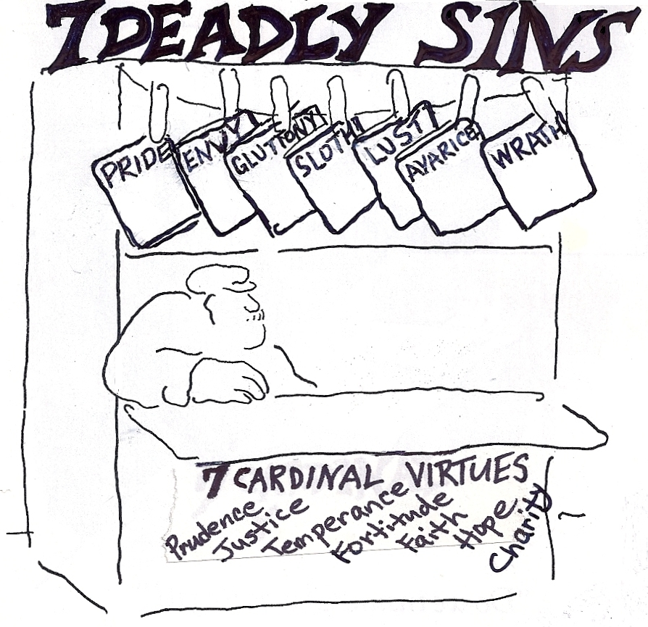

Seven
Sacraments
Baptism
Confirmation
Communion
Penance
Ordination
Matrimony
Unction

Seven Gifts
of the Holy Spirit
Fear of the Lord
Piety
Knowledge
Fortitude
Counsel
Understanding
Wisdom

Aristotle’s Golden Mean
-- Defect -- | BALANCE | + Excess +
cowardice | COURAGE | rashness
stinginess | LIBERALITY | extravagance
sloth | AMBITION | greed
humility | MODESTY | pride
secrecy | HONESTY | loquacity
moroseness | GOOD HUMOR | bufoonery
quarrelsomeness | FRIENDSHIP | flattery
self-indulgence | TEMPERANCE | insensibility
apathy | EQUANIMITY | irascibility
Hamlet’s  indecisiveness | Atticus’  SELF CONTROL | Don Quixote’s  impulsiveness
* Derived from The Story of Philosophy by Will Durant

Becoming a Knight
Page
Squire
Knight with an Accolade

Becoming a Guildsman Apprentice
Journeyman
Master with a Masterpiece
FOUR HUMOURS
Major  Element | Seat  of the Humor | Physical Traits  of the Humor | Personality  Characteristics
AIR | blood | hot & moist | sanguine
FIRE | choler, or  yellow bile | hot & dry | choleric
WATER | phlegm | cold & moist | phlegmatic
EARTH | black bile | Cold & drc | melancholy

Epicureanism vs. Stoicism

